109070032 廖品睿 report

1. How you implement your code

After splitting and parsing the lines in these data files ,I constructed a trie for every txt file and put the words I get in the trie for searching prefix and exact word.

For searching suffix , I reversed the word and put it in another reversed trie . So that I get two tries for every file I get in the data file, which shall consume lots of spaces.

Then , I pushed all the root nodes in the ROOTS vector to store it, in order to get access it quickly.

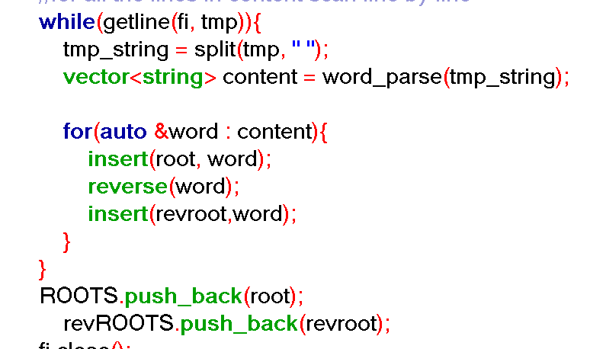

I getline each of the lines in query, and use if else statement to determine if I get a alphabet string or + operator or / operator and search the word in root or reverse root

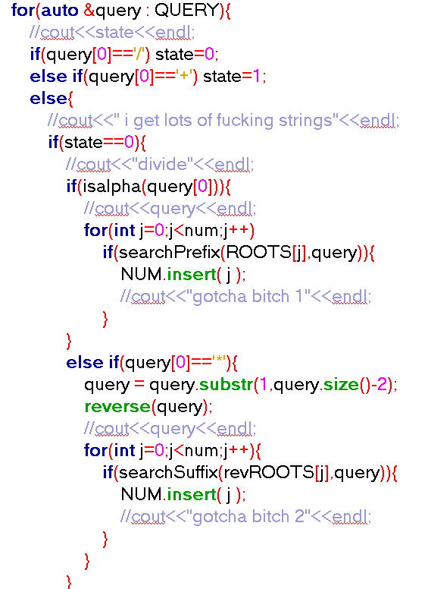

And I put the correct number files into a set called NUM to search in all the TITLES to get the correct titles

1. Challenges you encounter in this project

I included <set> to put the correct numbers in it , I initially used vector but it cannot merge the repeated numbers , so I spent a lot of time implementing vector , and I also tried to use linked list , but it was a failure too.

I included<time.h>to test the run time , used<ctype.h> to use isalpha function to make my code quicker.

Another challenge is I parsed the query and lost all the \* and “ symbols and took a lot of time figuring it out.

Also, I could not use the command window to run my code anyways , so I used the terminal of visual studio code to run instead .i still could not figure out why my cmd does not define g++.

Another challenge was that I initially could not write in the output file because

Opened and closed the file repeatedly so that I could only get the last line of output.

Another mistake I made in the middle is that I pushed the root into ROOTS too many times so that there are more roots than the number of files and it printed the wrong number of files initially , after I found the problem , I moved the push back function to the end of while to ensure after a whole complete tree with the title words are constructed, I can then push back the root.

I also encountered some problems when I was searching the exact word and prefix because prefix does not necessarily need to detect the endofword=true to return true.

1. References that give you the idea

<https://www.geeksforgeeks.org/trie-insert-and-search/>

<https://www.cnblogs.com/gaochundong/p/suffix_tree.html?fbclid=IwAR1NymlaMuUp-mdBStWhtEqfkX9tv9c6B2GErPirsnfPm2GZOwGN70CyVww>

<https://www.murrayc.com/permalink/2016/08/19/suffix-tree-ukkonen-c/?fbclid=IwAR3qwLA_Sb1utkFxPRaauAIAyygJdm25lOQUnD0fN3MnlO4gWt5IWt5Mae4>

These are the references for understanding trie and suffix trees

Hope you have a nice day!!